Tableau Project

Step 1: Open Tableau 10. x

Step 2: On the home page, under Connect, under a file, click Excel.

Step 3: Browse and connect to the Global Financial Development Database - 2018 Excel file.

Step 4: Drag and drop Data July 2018 tables to the canvas area.

Step 5: Click on the Add button to connect the Insurance Sample Dataset Excel file.

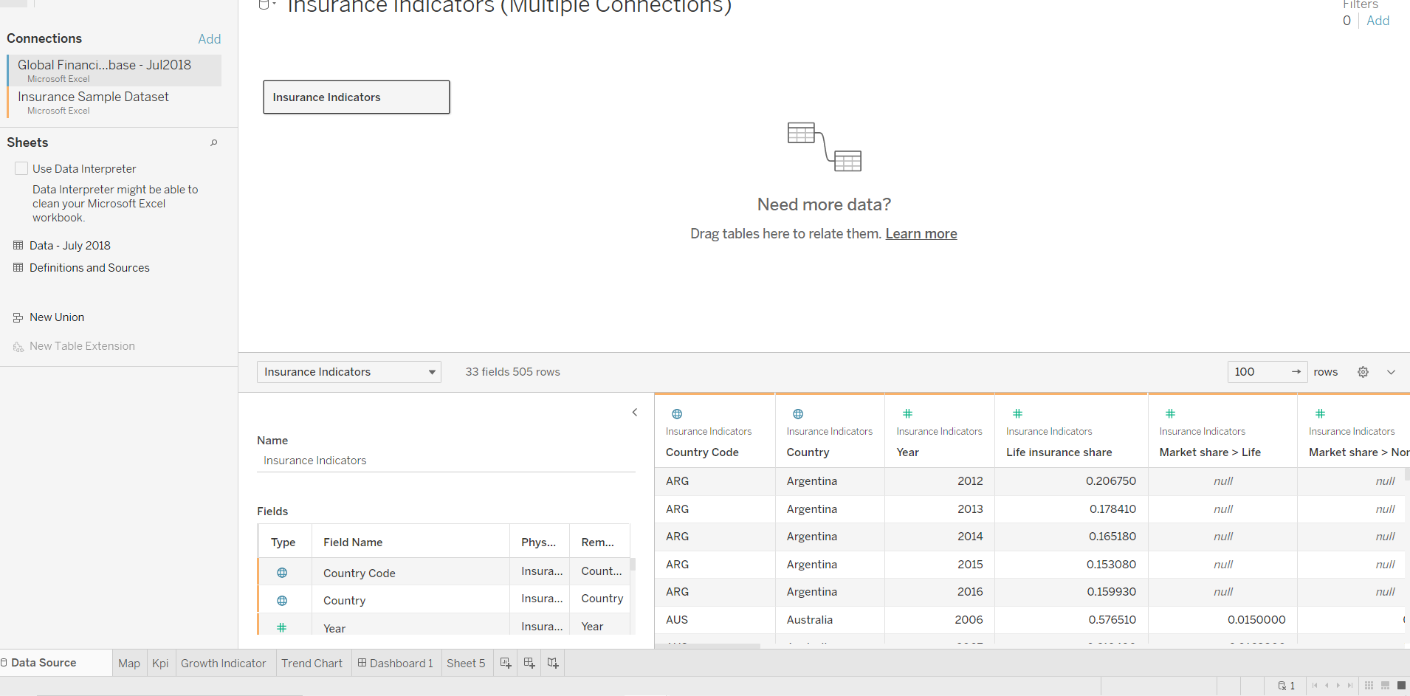

Step 6: Go to Sheet one and rename it as MAP.

STEP 7: To Create a MAP, drag Country from Insurance Sample Dataset and put on Detail Mark card and then go to automatic and click map. Then drag Income from Global Financial Development Database to filer and select all and click on show filter. Drag Income to Colour Mark Card and Country Code to text Mark card.

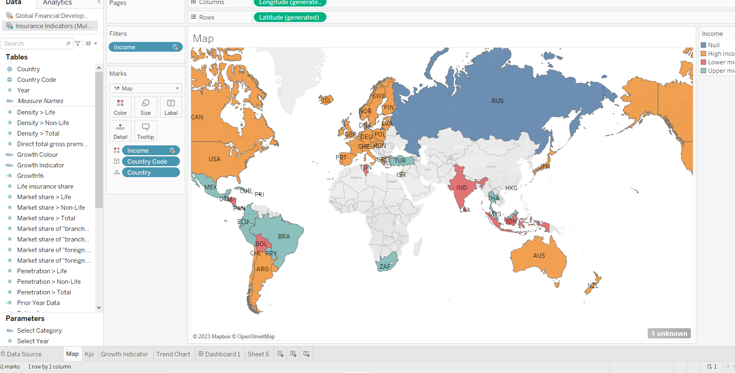

Step 8: Create 2 Parameters , One for Select Year and Another Select Category.

Step 9: To create Parameter go to Down key below Filter button in Data panel , And click on Create Parameter. For Year parameter click on Date datatype and for Select Category Click on String Data type.

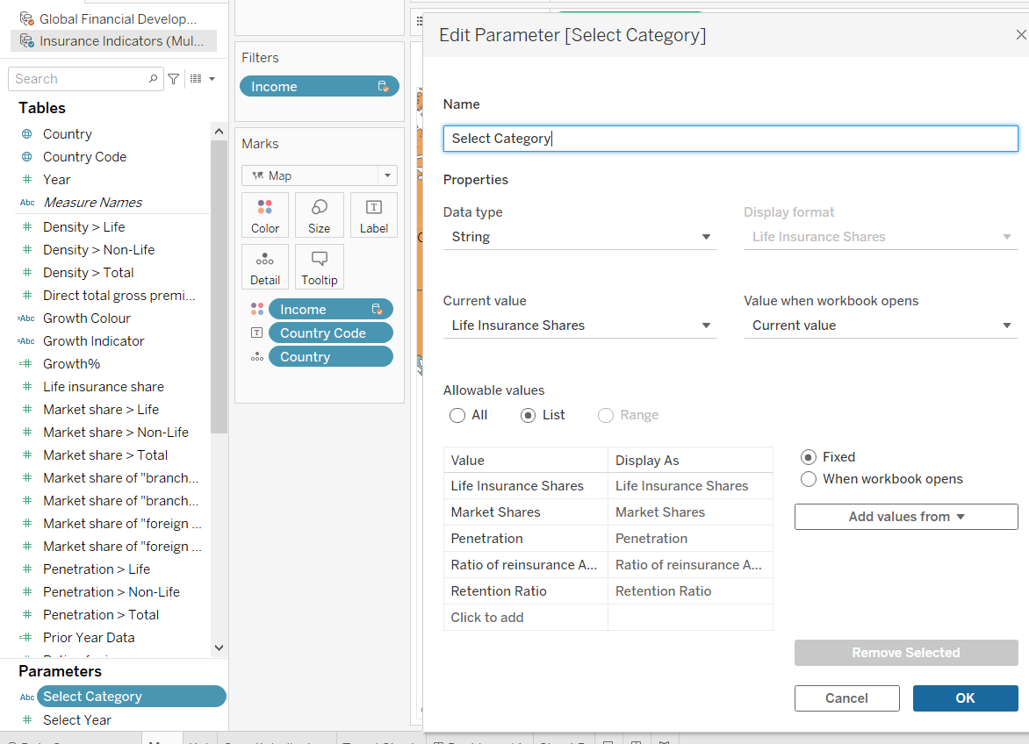

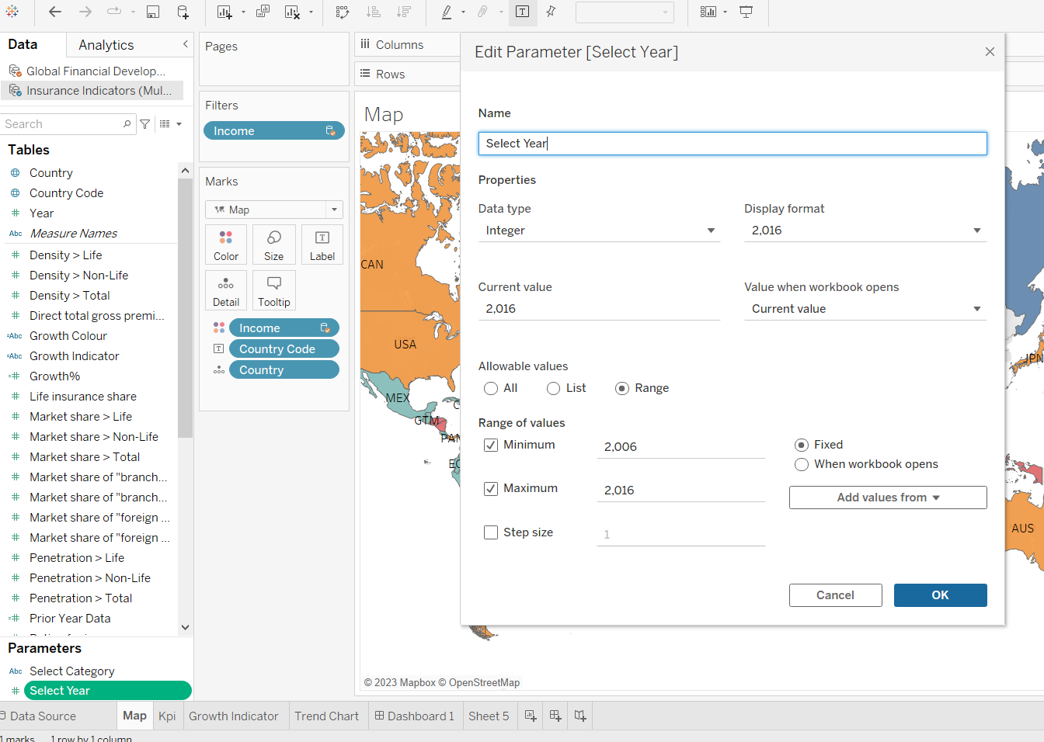

Step 10: Create Calculated Field: To Select Category, select year and prior year Growth %

Click on Analysis Pane , and then Calculated Field and do calculations for the following. Select Category is for : to Select Category Parameter select year: Selected Period Value prior year : Comparison Period Value Growth : For Growth %

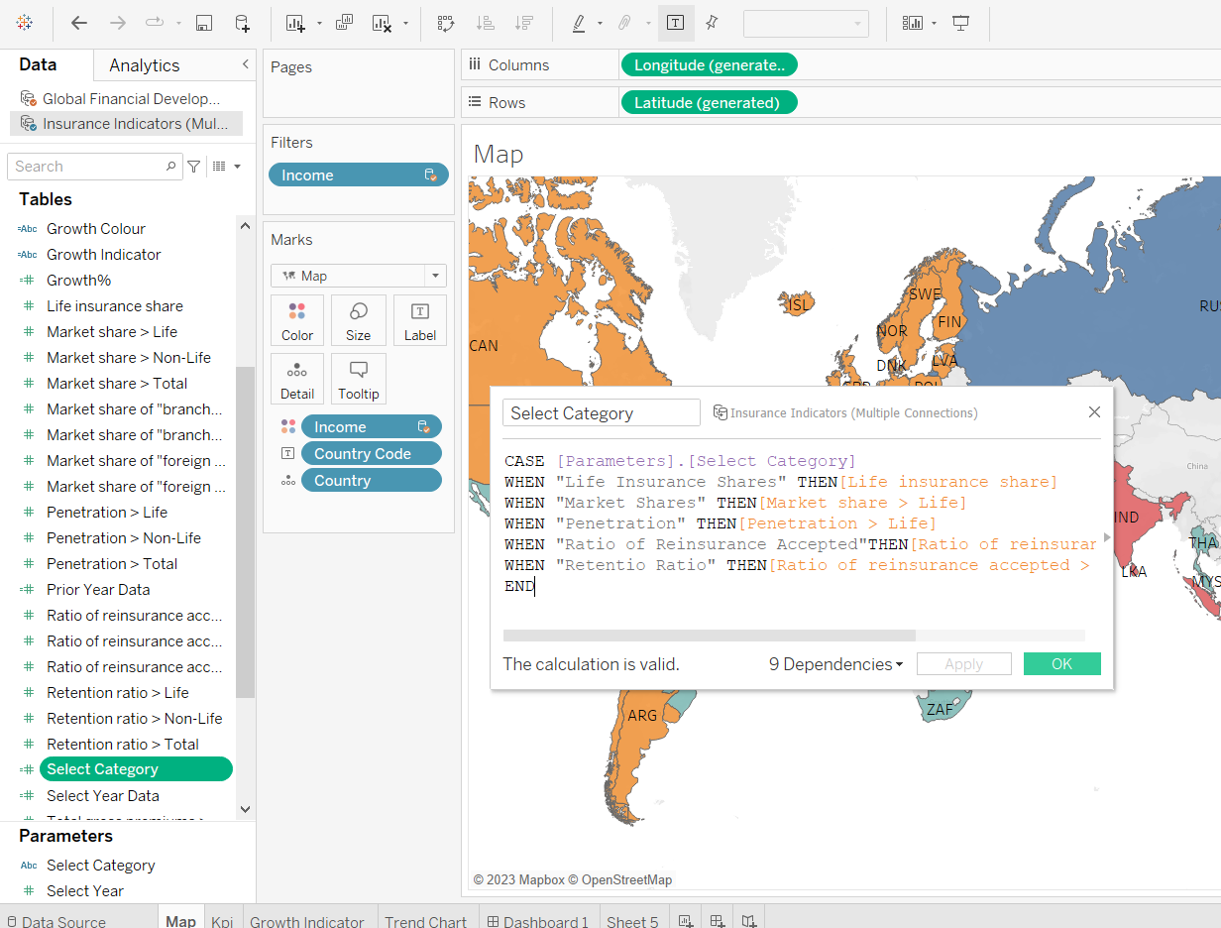

Step 11: Create a KPI Calculator: Go to new sheet and rename it KPI table and click on Sheet title and insert Select Category Click on Parameters and Show Parameter

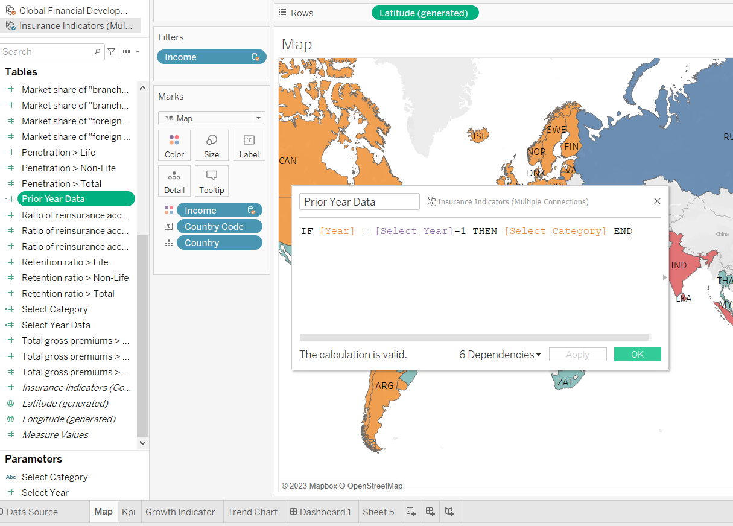

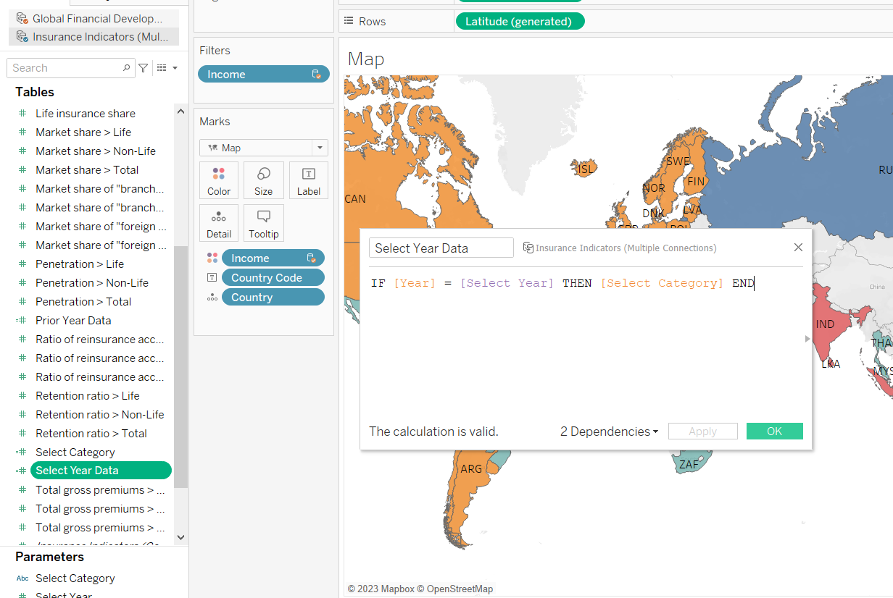

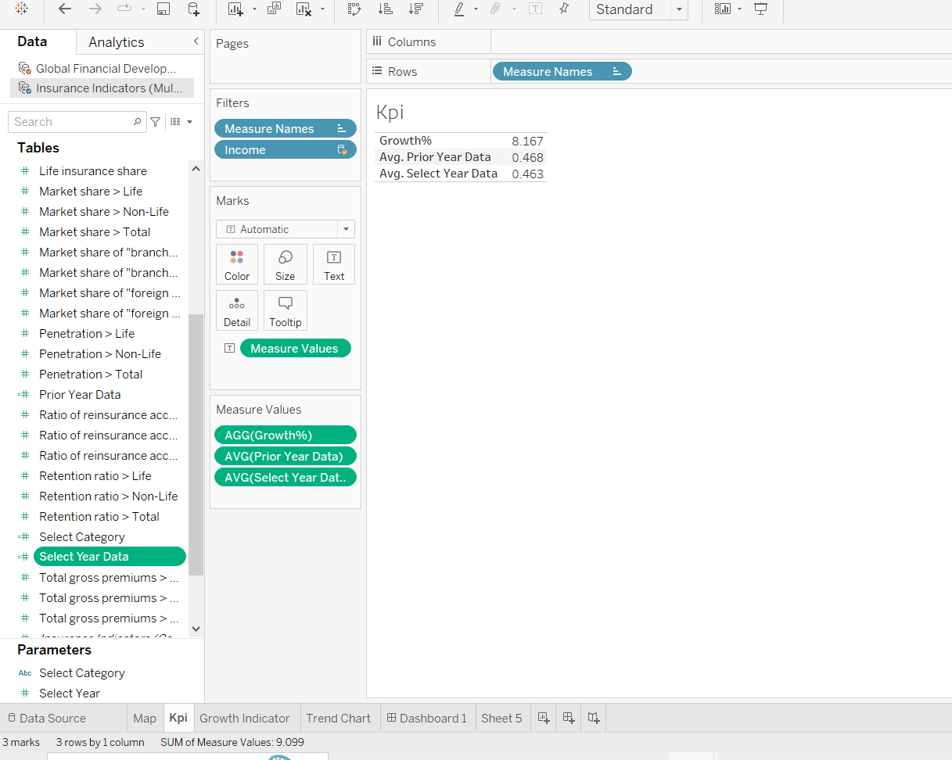

Step 12: To create a growth indicator: Create 2 Calculated Field: Growth Colour and Growth Indicator:

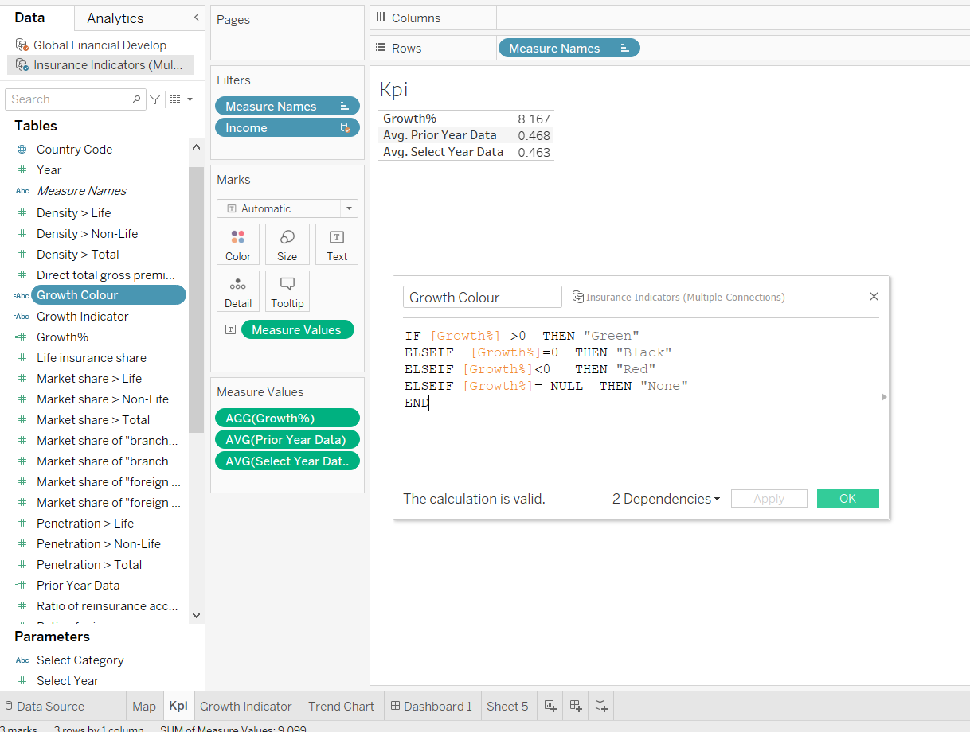

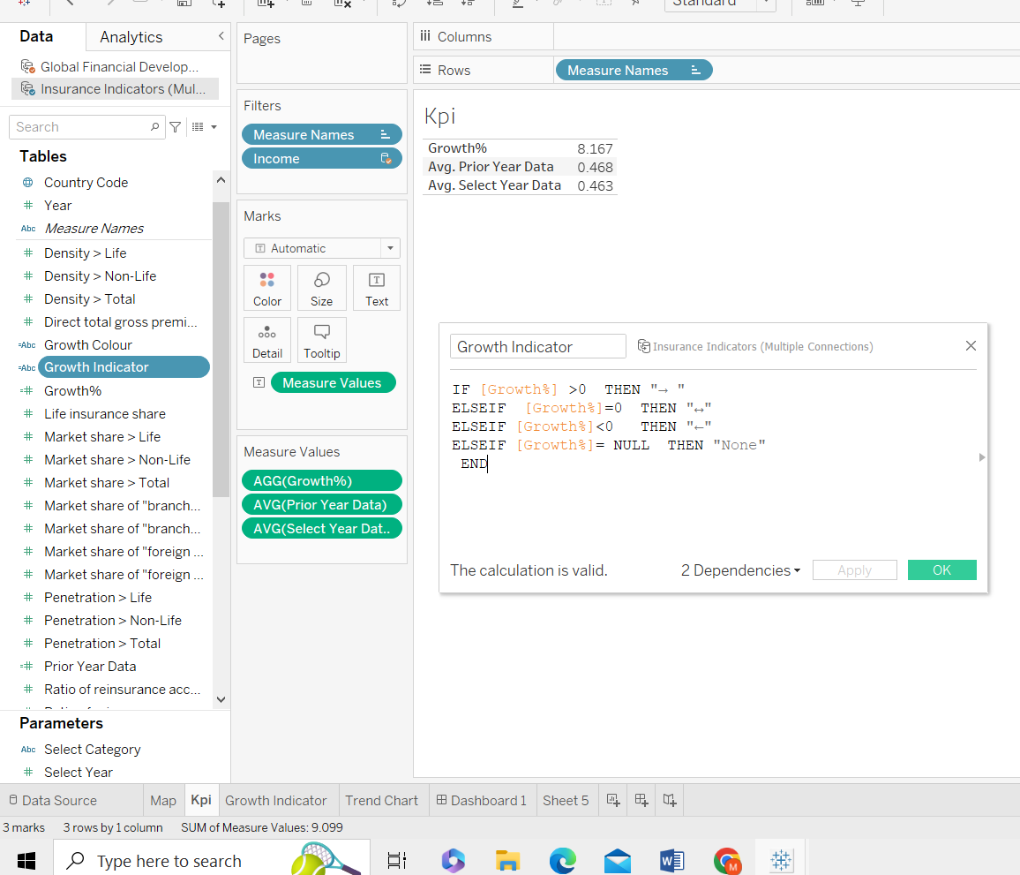

Step 13: Growth Indicator Visualization : Go to New Sheet and rename it Growth Indicator Click on Parameters and Show Parameter. Drag Growth Colour to Colour and Growth Indicator To text.

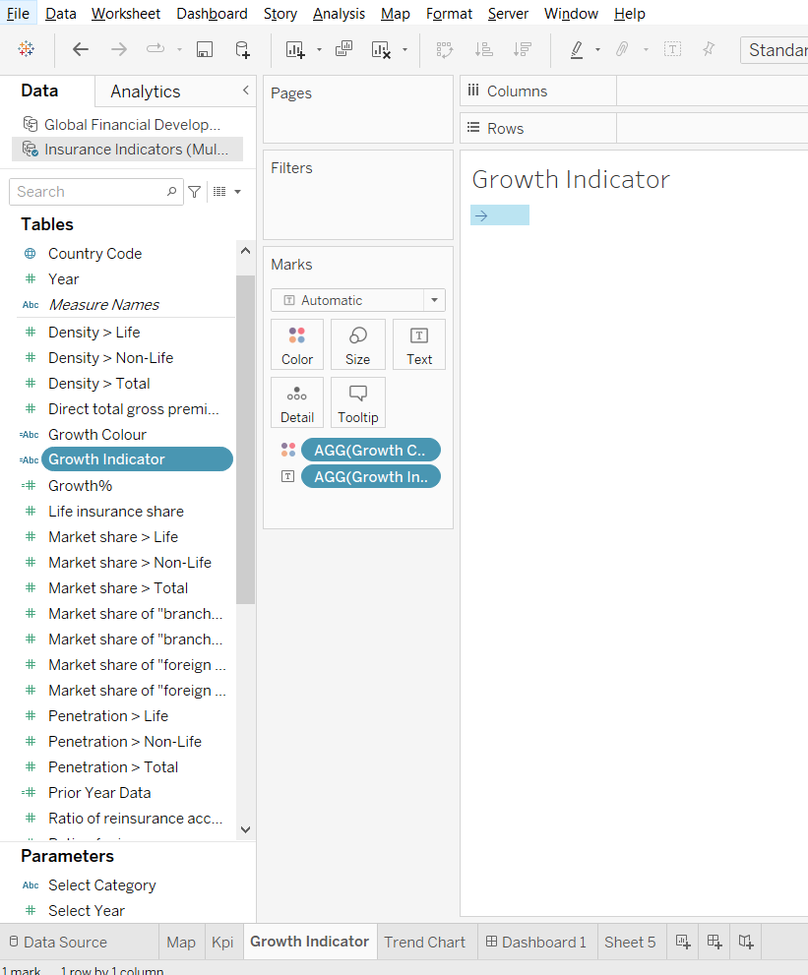

Step 12: To Create Trend Chart: Go to New sheet and rename it Trend Chart. Click on Parameters and Show Parameter. Drag Year to Columns and Select Category Measure to Rows. Year to Pages [To make a Motion Chart] and click on Show history and Trails.

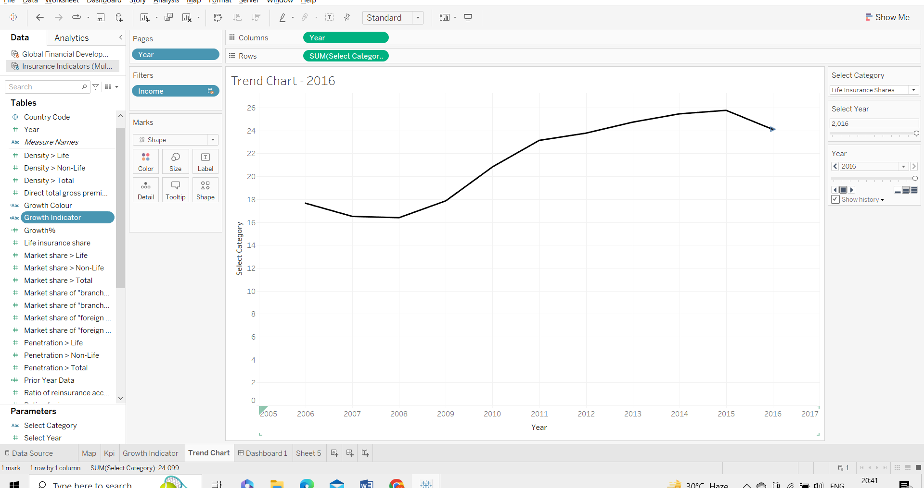

Step 14: Create a Dashboard: Click on Dashboard button . Go to Size and click Automatic. Go to Objects and click on Horizontal, Then Vertical , and then Horizontal, Drag Map to sheet , From Objects drag web Page to sheet. Then Go to Dashboard , Click Action -> add action -> go to URL -> edit action-> Source sheet -> Map and Run action -> Select And add URL in URL bar

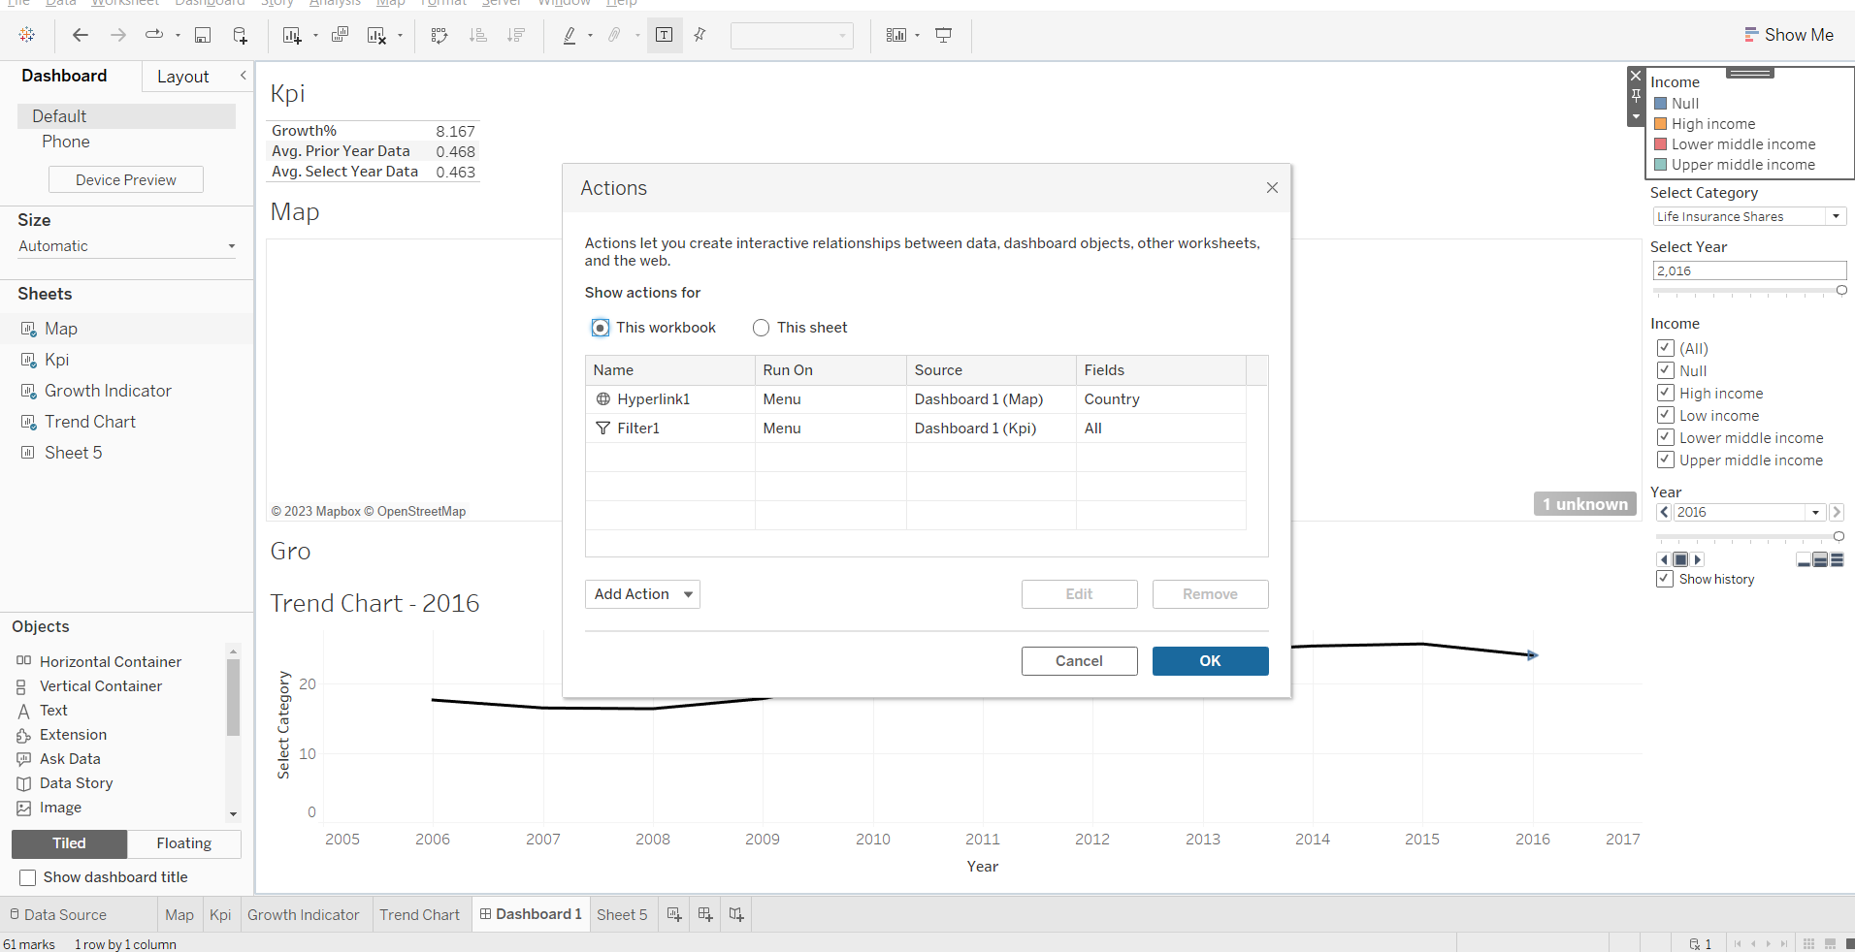

Step 15: Dashboard ready to slideshow.

